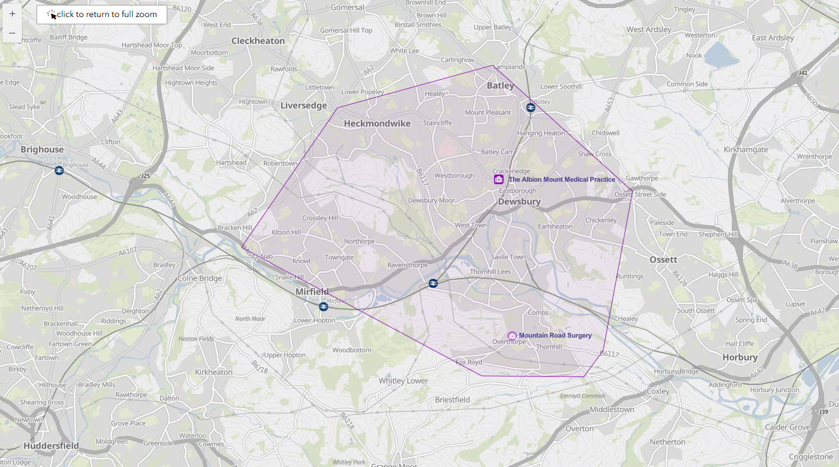ALBION MOUNT MEDICAL PRACTICE

CATCHMENT AREA